**Antimicrobial Stewardship: Laboratory Update**

Blood cultures are sent to St. Peters microbiology department where they use the BioFire® FilmArray® Blood culture Identification 2 Panel technology. In the example below the assay detected both Enterobacterales and *Escherichia coli***.**

**Enterobacterales is NOT *Enterobacter* sp.**

Enterobacterales represents the group of gram negative bacteria that is commonly present in the gastrointestinal tract such as: E. coli, Enterobacter, Klebsiella, Proteus, Salmonella, and Serratia. If one of organisms in that group is detected, the Enterobacterales component will also be positive.

**This means the patient has *E. coli* bacteremia, NOT *Enterobacter* AND *E. coli*.**

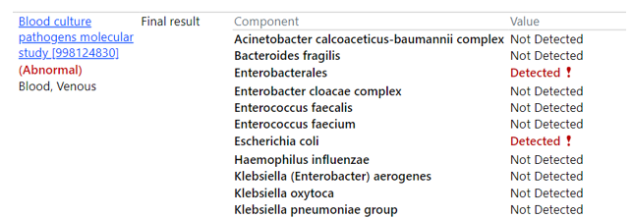

Any questions, please call the antimicrobial stewardship team at 448-6177 or 448-5031.

Prepared by: Lisa Avery, Pharm.D.