 

St. Joseph’s Health Partners Workflow: IP Provider Management of Expiring Orders

Section I

Address Expiring Orders

To address an expiring order, click one of the following buttons:

• **Renew**: Extend the order.

**Note**: You can't renew blood transfusions.

• **Reorder:** Extend a continuous medication or procedure that has already expired.

• **Let Expire**: Inform other clinicians that you don't intend to renew or reorder. A note appears with your

name, the date, and the time.

• **Modify**: Change the order details.

• **Discontinue**: Stop the order now.

**NOTE**: Instead of renewing, you could let the order expire and write a new order. However, renewing

saves you a few clicks. Also, renewed orders don't require pharmacy verification, so medications

appear in the ADS sooner. Reordering requires pharmacy verification, but still saves you clicks.

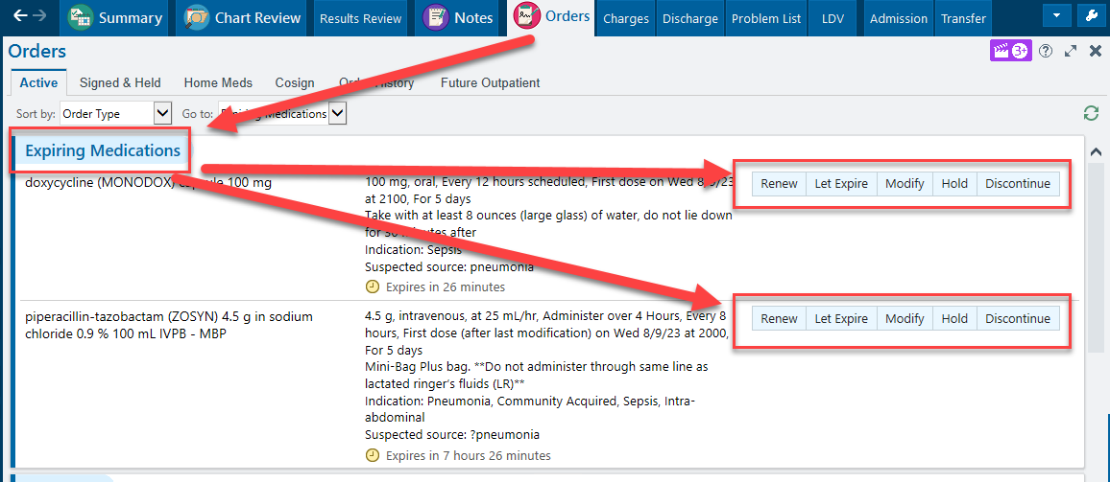

Reorder Expired and Completed Orders

Recently expired and completed orders stay on the **Active** tab for 24 hours, so you can easily reorder them

instead of rewriting the orders. Just click **Reorder**.

After 24 hours, go to the **Order History** tab, select the expired order, and click **Reorder**

