Diabetic supplies for discharge

Navigators🡪 General Discharge

For discharge orders please remember:

If you order glucose meter🡪 order test strips and lancets

If you order insulin via vial🡪 order syringes

If you order insulin via pen🡪 order pen needles

If you order bolus insulin🡪order sliding scale (or set dose)

* If you select orders (after visit/dc orders); you can follow users. Jamila Benmoussa, MD (Endocrinologist with St. Peters) has several order sets and Medications that may be helpful to utilize.

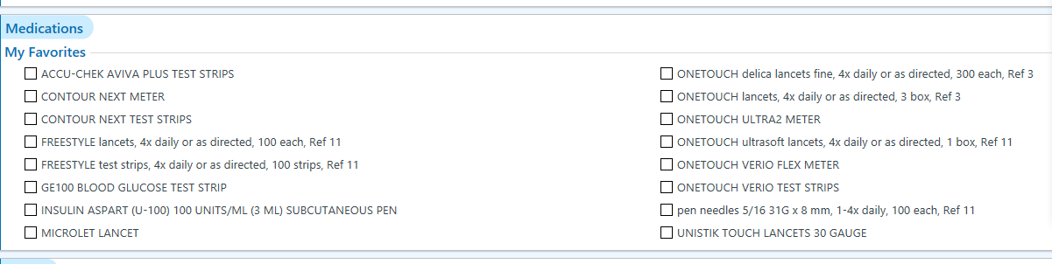

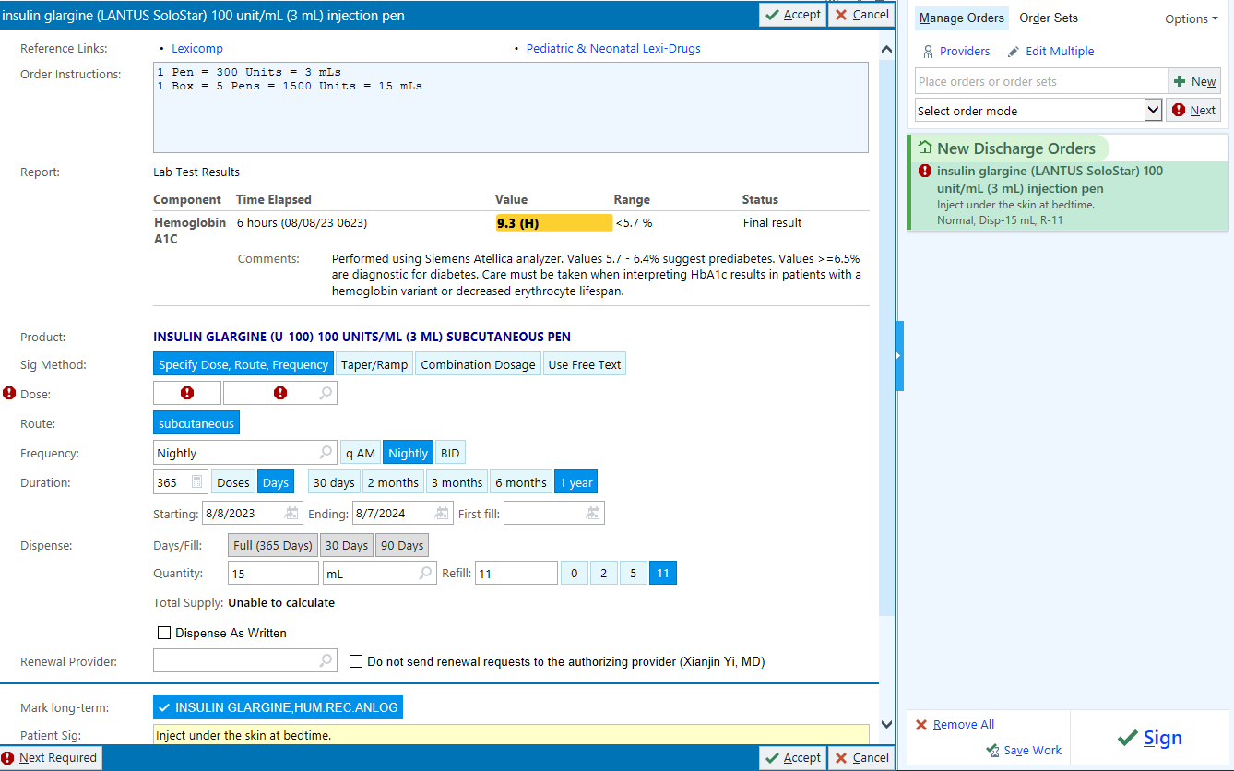**Example for ordering Lantus at discharge**

**Savings on Diabetic supplies and medications**

**Walmart**

**Insulin (Walmart brand)**

* Novolin R
* Novolin N
* Novolog 70/30

1 (10ml) vial= $24.88

1 box of 5 pens= $42.88

**Reference:**

|  |  |  |  |  |
| --- | --- | --- | --- | --- |
| **Action** | **Name** | **Onset** | **Peak** | **Effective Duration** |
| Short Acting | Regular (Novolin R) | 30-60 min | 2-3 hrs. | 5-8 hrs. |
| Intermediate | NPH (Novolin N) | 2-4 hrs. | 4-10 hrs. | 10-16 hrs. |
| Intermediate + Short | Novolog 70/30  70% NPH + 30% Reg | 30-60 min | Dual peaks | 10-16 hrs. |

**Oral medications**

* Glimepiride (1mg, 2mg, 4mg) 30 tablets, $4
* Glipizide (5mg, 10mg) 60 tablets, $4
* Metformin (500mg, 850mg, 1000mg) 60 tablets, $4
* Metformin ER 500mg 120 tablets, $4
* Metformin ER 750mg 60 tablets, $4
* Glipizide ER (2.5mg, 5mg, 10mg) 30 tablets, $9
* Glyburide/Metformin (2.5mg-500mg, 5mg-500mg) 60 tablets, $9

**Glucometers**

* Reli On Premier Classic glucometer $9
* Reli On premier Blu (Bluetooth capabilities) $18.98
* Reli On premier test strips
* 25 ct. $5
* 50 ct. $9
* 100 ct. $17.88
* Reli On lancing device $5.92
* Ultra-thin lancets 100 ct. $1.62

**Price Chopper Pharmacy**

Diabetes Advantage Program

**Oral Medications**

* FREE: Glimepiride, Glipizide, Glipizide XL, Glyburide, Metformin, Metformin ER (500mg & 750mg tablets)

**Glucose Meters**

* GE100 Blood glucose meter: FREE
* GE blood glucose test strips, 50 ct. $11.99
* Lancet device and lancets: FREE

Insulin Pen tips (4,5,6,8mm) 100 ct. $9.99

**Assistance with prescription Costs through Novo Nordisk**

Link: [www.novocare.com](http://www.novocare.com)

Medications included in this program Include: Fiasp Insulin, Levemir Insulin, Novolog Insulin, Novolog 70/30 Insulin, Ozempic Injection, RYBELSUS, Tresiba Insulin, Victoza Injection, Xultophy 100/3.6 Insulin degludec and liraglutide injection

**Patient Assistance Program**: Provides medication at no cost to those who qualify (Household income below 400% of FPL, no insurance, not receiving any other federal/state/gov program)

Patient can fill out application online or print it and fill it out. Last step of the application is PCP or MD who would be signing for Insulin. Patient will need the providers email address. The application is delivered electronically to the provider for signing. The medications are sent to the provider address for appropriate dispensing to the patient. This is a FREE program for those who qualify.

**Savings offer:** For commercial insurance, pt.’s may be eligible to pay as little as $25 per 30-day supply for up to 24 months (co-pay/savings cards) can be downloaded on the novocare website or texted to patients’ phone

**My $99 Insulin:** Patients may be eligible for monthly supply of any combination of Novo Nordisk Insulin products (up to 3 vials or 2 packs of pens). Offer is available each month during a calendar year. *Please note that 2 packs of pens may last a patient longer than 1 month*