**UPDATE - Placing Diet Orders for Adults**

|  |
| --- |
| **Application:** Epic TogetherCare Inpatient |
| **Affected Role:** Inpatient Providers, Inpatient Nurses, Dietitians. |
| **Date:** 7/13/23 |
| **Epic Changes Taking Effect:** 07/23/2023 |

* As of July 23, 2023, the free text diet comment section is being deleted due to lack of interface with Food Service Patient Menu Computer System, for order accuracy and patient safety.
* See page 2 for the alternative, free text nutrition-related instruction options.
* Order diets by selecting 1) the primary diet type and 2) the required diet modifiers in one order. This is and has always been a two-step process.
* For diet ordering assistance the Dietitian’s office is available for assistance during the hours of 7:30 AM-4:00 PM at extension 85131

**Ordering NPO Diet in Epic**

* Ordering diets in Epic is a two-step process.
* Example: To order “Adult NPO Diet” – choose the type of diet (shown below) AND click Accept.
* Error message disappears when order is correctly placed.

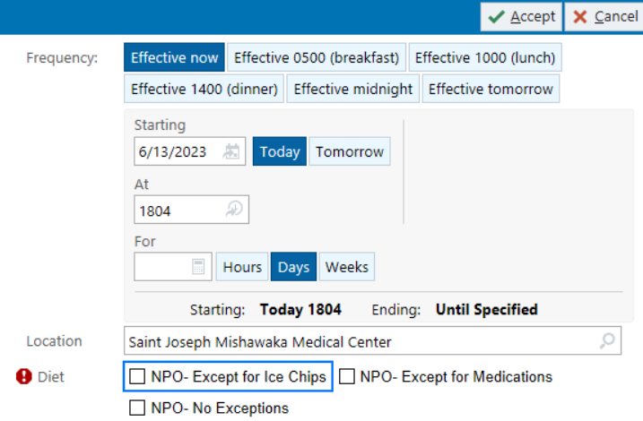

**Ordering Adult Diets in Epic**

* Step 1: Choose from the 6 diet types (1. Diabetic, 2. Cardiac, 3. General, 4. Fluid Restrictions, 5. Modified Consistency or 6. Bariatric/GI) along with miscellaneous diet list, to create the order.
* Step 2: Choose the appropriate diet modifier(s). Both belong in **one** diet order.
* **Diabetic Diet Type** choices are shown below:



* **Cardiac Diet Type**:

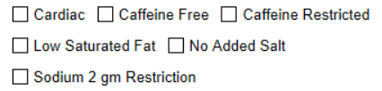

* **General Diet Type**:

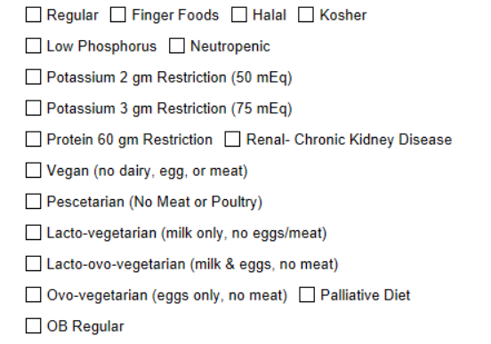

* **Fluid Restrictions** **Diet Type:**

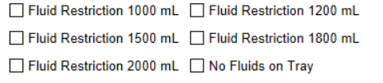

* **Modified Consistency Diet Type**:

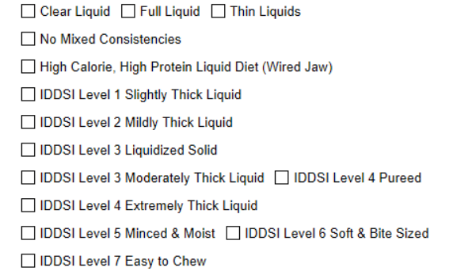

* **Bariatric / GI Diet Type**:

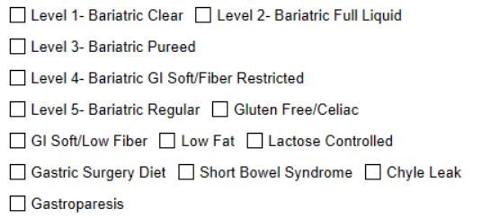

* **Miscellaneous diet modifiers:**

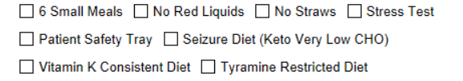

**Adding Free Text Nutrition Related Instructions in Epic**

* **Separate free text nutrition instructions are available to communicate:** 
  + Menu preferences
  + Mealtime patient feeding instructions
  + Physician to nurse vs physician to speech pathologist instructions to advance diet

**Use the following navigation means as the comment box will no longer be available.**

**Dietary Communication order**

* Used to communicate a patient’s food preferences or other miscellaneous nutrition instructions relating to meals (i.e. – patient receiving breakfast meals from home, please end breakfast tray by 8am daily d/t dialysis schedule).
* Diet modifiers can NOT be listed here as they will not interface with the menu software and will be missed. All modifiers must be chosen from pre-built types as shown above.
* Diet allergies can NOT be listed here as they will not interface with the menu software and will be missed.

**Diet Instructions to Nursing**

* Used for SLP (or other provider) to share pt feeding instructions with nursing
  + Aspiration precautions.
  + Full assist to feed.
  + PO meds crushed.
  + Use med cup for liquids
  + One on One feed or Full Nursing Supervision at Mealtime.